lab 1 report:

1.bubble sort: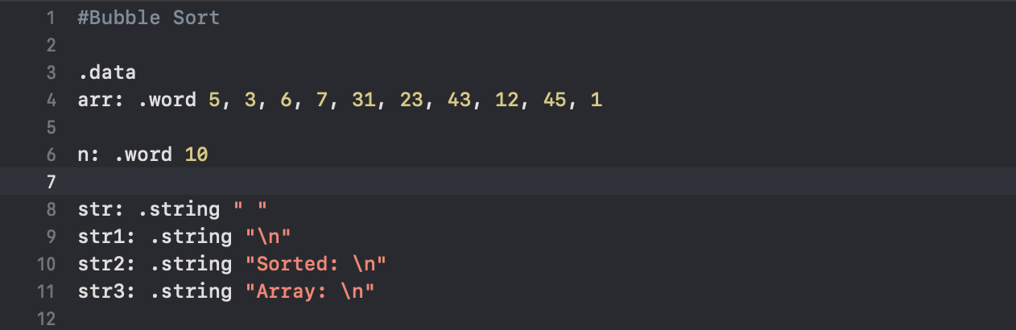

(1)data

arr: 排序的array

n: 多少個數字

(2)main function:

pri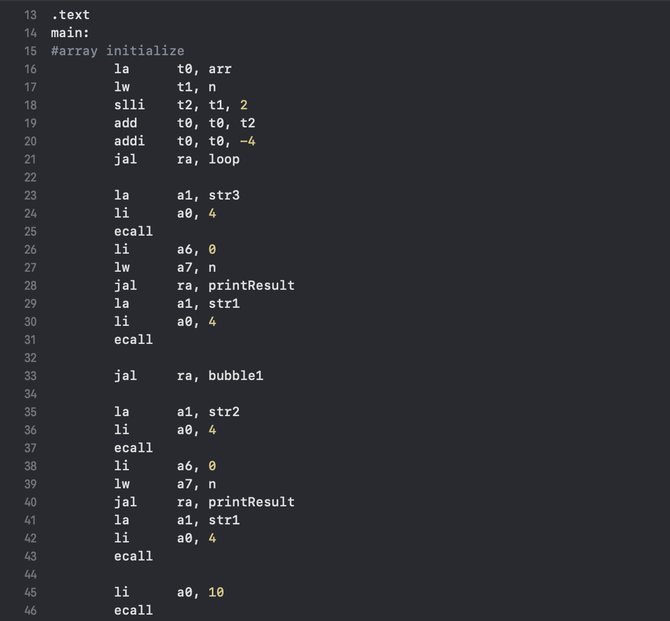nt “Array:”

print array

bubbleSort()

print “Sorted:”

print array(sorted)

(3) loop function:

把array[n]～array[0]存到s0[n]～s0[0]

(4) bubble1:

i=0

(5) bubble2:

j=i-1

loop i:

(i=0), i<n, i++

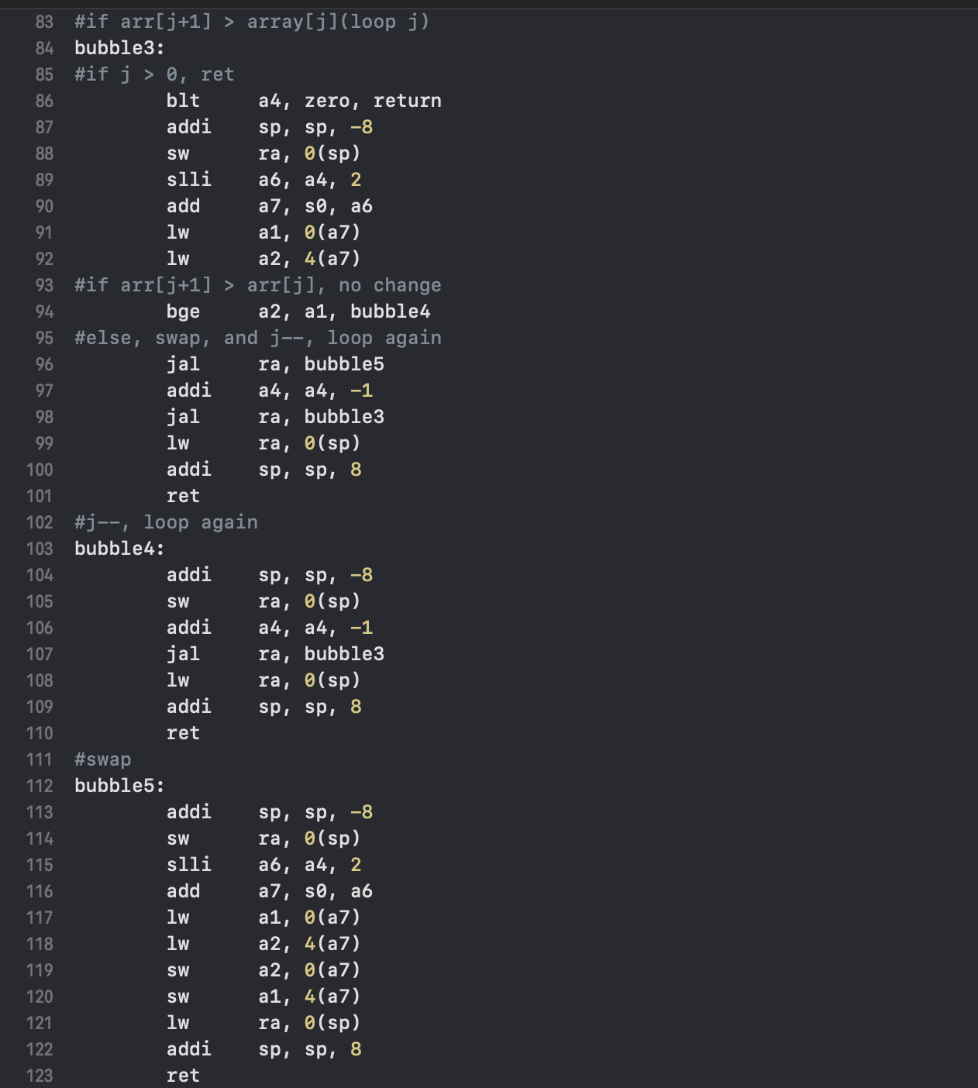

(6) bubble 3:

loop j:

(j=i-1), j>0, j- -

{

if(arr[j+1] > arr[j]):

swap

}

(7) bubble 4:

如果arr[j] < arr[j+1], j- - 繼續

(8)bubble 5:

swap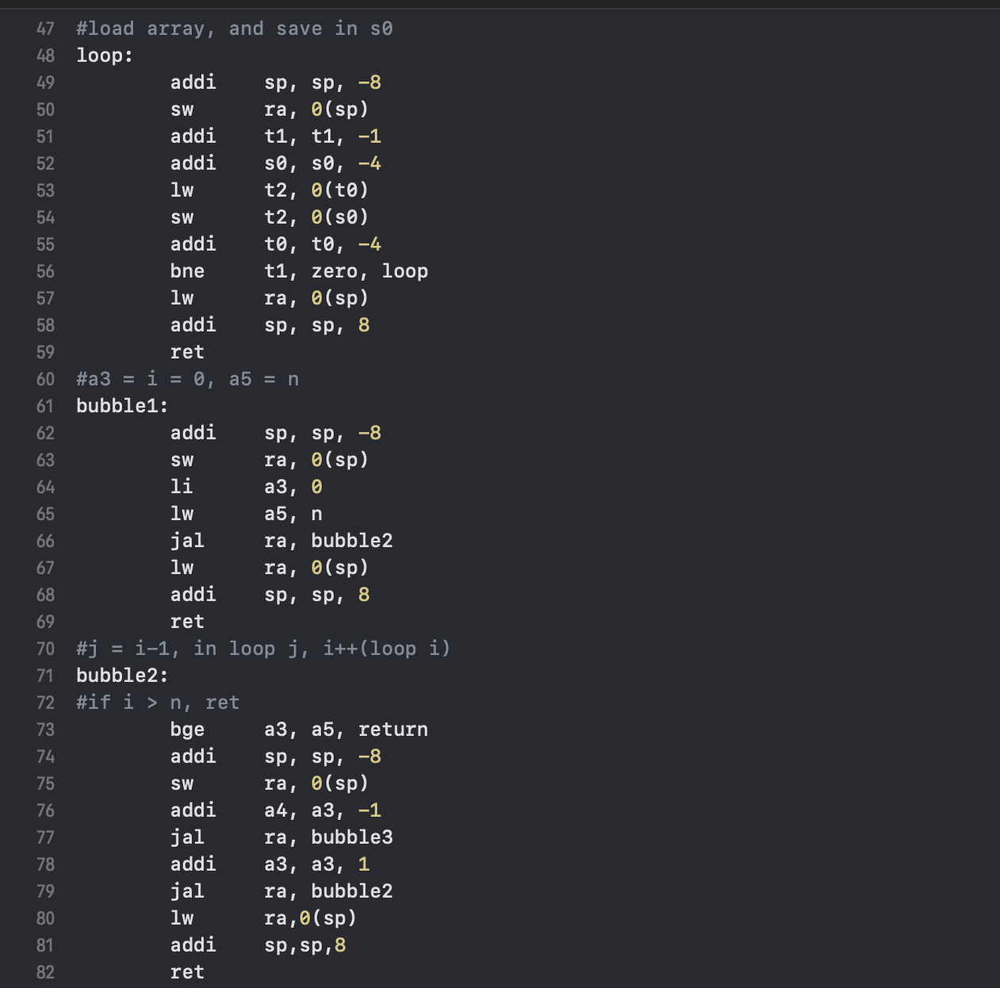

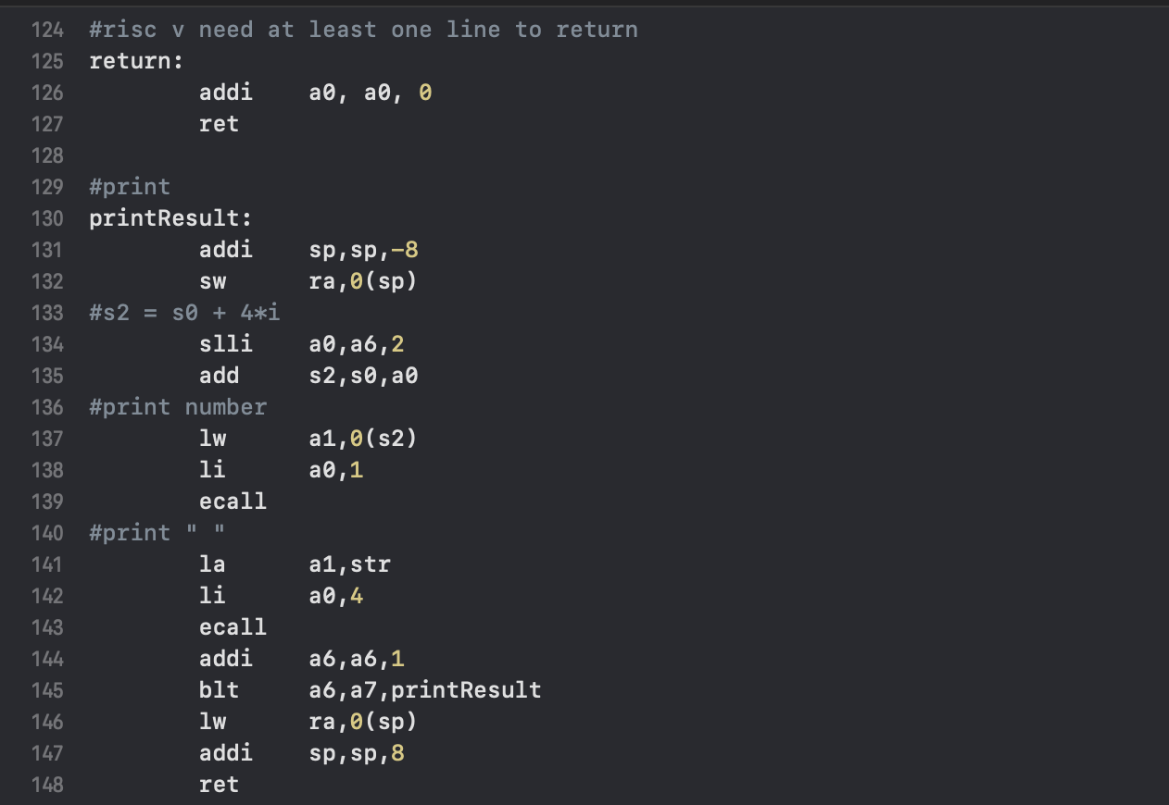

(9)return function:

如果沒有內容無法ret，所以加一行不影響答案的code

(10)printResult function:

遞迴print

2.fibonacci: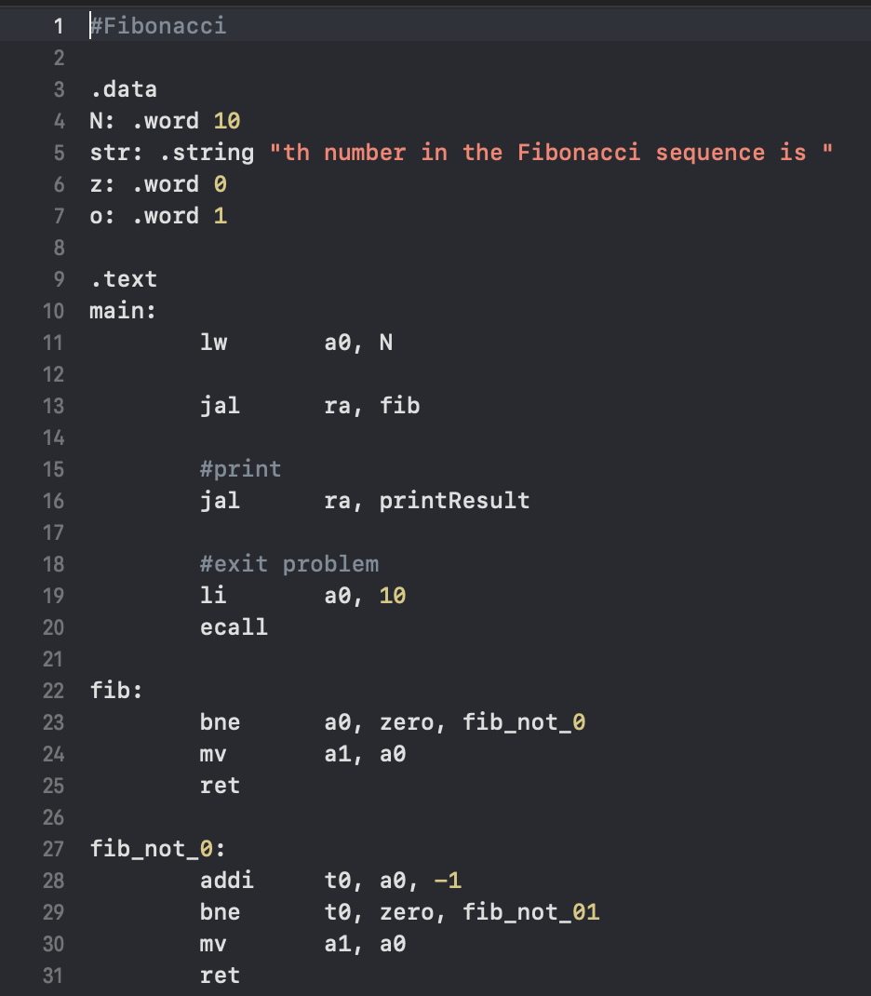

(1)data:

n: 第幾個數字

(2)main function:

fib()

printResult()

(3)

fib:

if(a0 != 0):

go to fib_not_0

else:

a1=0

(4)

fib_not_0:

if(a0 != 1):

go to fib_not_01

else:

a1=1

(5)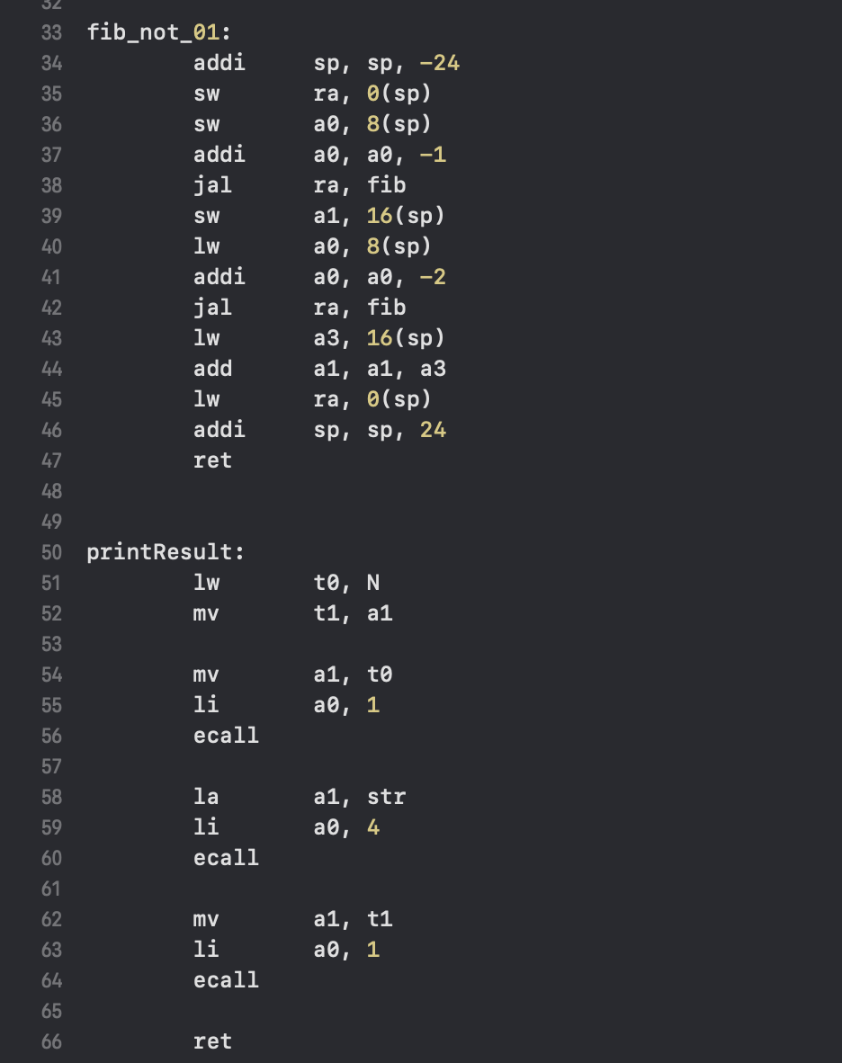 fib_not_01:

a1 = f(n-1)+f(n-2)

(6)print:

printResult

3.GCD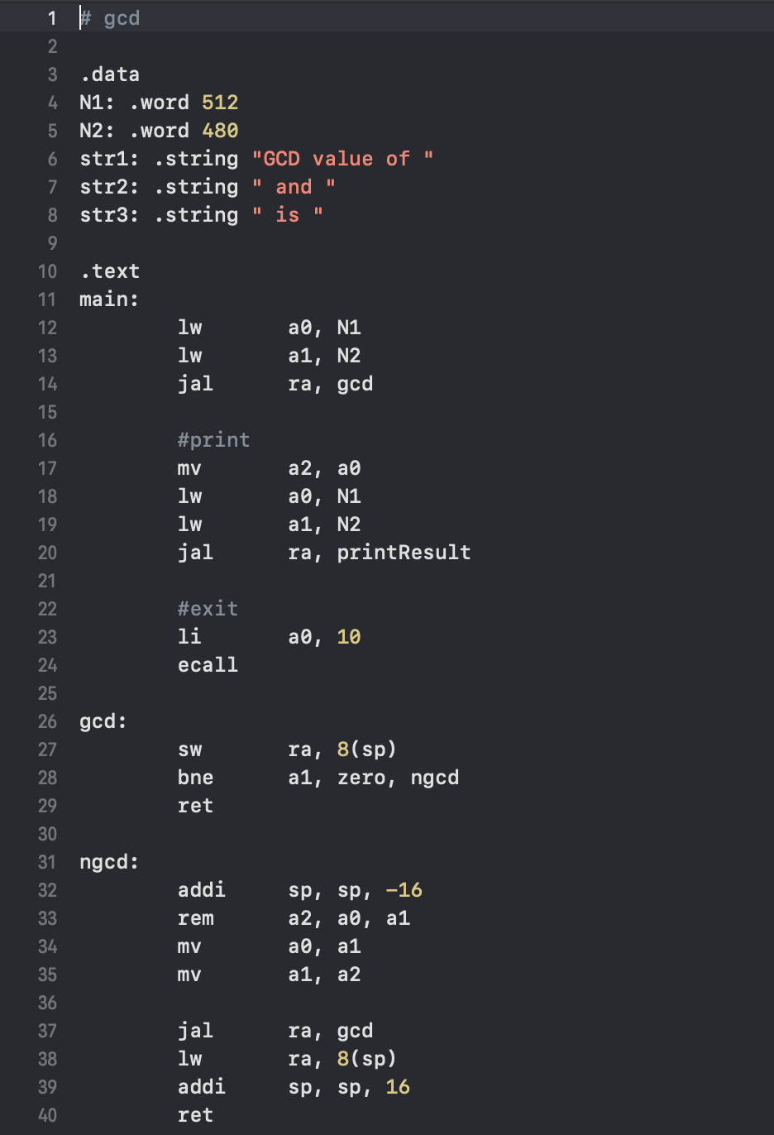

(1)data:

N1: 大數

N2: 小數

(2)main function:

load N1(a0), N2(a1)

gcd()

print

(3)gcd:

if(a1 != 0):

ngcd

else:

ret

(4)ngcd:

a1=a0%a1

a0=a1

(5)printResult:

print a0